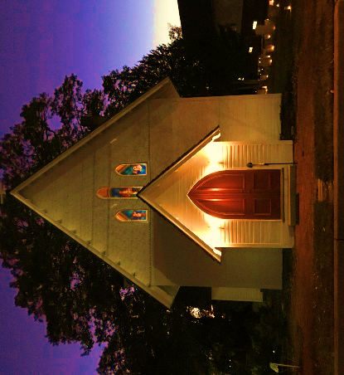 | All Saints Day Evening  Service of Remembrance  November 1, 2023  St. George’s Episcopal Church  Glenn Dale Maryland
Officiant: Since we are surrounded by so great a cloud of witnesses, let us run with perseverance the race that is set before us, looking to Jesus the pioneer and perfecter of our faith.

Blessed be the one, holy, and living God:
All: Glory to God for ever and ever.
Holy One, you sent Jesus to bind up the brokenhearted:
All: And comfort those who mourn.

The Lord be with you:
And also with you.
Let us pray together: Almighty God, we remember this day before you your faithful servants buried in this holy ground; and we pray that, having opened to them the gates of larger life, you will receive them more and more into your joyful service, that, with all who have faithfully served you in the past, they may share in the eternal victory of Jesus Christ our Lord; who lives and reigns with you, in the unity of the Holy Spirit, one God, for ever and ever. Amen.

A Reading from the Revelation to John
I saw the holy city, the new Jerusalem, coming down out of heaven from God, prepared as a bride adorned for her husband. And I heard a loud voice from the throne saying,
"See, the home of God is among mortals.
He will dwell with them as their God; they will be his peoples,
and God himself will be with them; he will wipe every tear from their eyes.
Death will be no more; mourning and crying and pain will be no more,
for the first things have passed away."
And the one who was seated on the throne said, "See, I am making all things new." Also he said, "Write this, for these words are trustworthy and true." Then he said to me, "It is done! I am the Alpha and the Omega, the beginning and the end. To the thirsty I will give water as a gift from the spring of the water of life. Those who conquer will inherit these things, and I will be their God and they will be my children.”
The Word of the Lord.
Thanks be to God.
Psalm 148 read responsively
Praise God from the heavens; praise God in the heights above.
Praise God, all angels; praise God, all his heavenly hosts.
Praise God, sun and moon; praise God, all you shining stars.
Praise God, you highest heavens and you waters above the skies.
Praise God from the earth, you sea creatures and ocean depths,
lightning and hail, snow and clouds, and stormy winds.
you mountains and all hills, fruit trees and all cedars,
wild animals and all cattle, small creatures and flying birds,
rulers of the earth and all nations,
young and women, old men and children.
Let them praise the name of the Most High,
God’s name alone is exalted; God’s splendor is above the earth and the heavens.
God has raised up for the people a horn,
the praise of all faithful servants, of Israel, Praise the Lord.

At the conclusion of the psalm, all say together
Glory to God, Source of all being, Eternal Word, and Holy Spirit;
as it was in the beginning, is now, and will be forever. Amen.

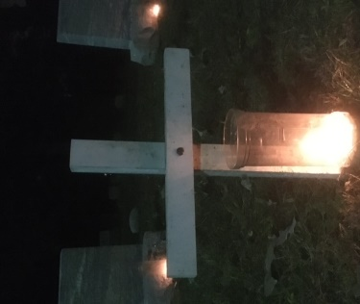

The Holy Gospel of our Lord Jesus Christ according to John.
Glory to you, Lord Christ.

John 6:37-40
Jesus said, “Everything that the Father gives me will come to me, and anyone who comes to me I will never drive away, for I have come down from heaven not to do my own will but the will of him who sent me. And this is the will of the One who sent me, that I should lose nothing of all that he has given me but raise it up on the last day. This is indeed the will of my Father, that all who see the Son and trust in him may have eternal life, and I will raise them up on the last day.”

The Gospel of the Lord.
Praise to you, Lord Christ.

Reflections The Rev. Connie Reinhardt
The Celebrant invites all to stand and says

In the assurance of eternal life given at Baptism, let us proclaim our faith and say,
I believe in God, the Father almighty, creator of heaven and earth.
I believe in Jesus Christ, God’s only Son, our Lord.
He was conceived by the power of the Holy Spirit and born of the Virgin Mary.
He suffered under Pontius Pilate, was crucified, died, and was buried.
He descended to the dead.
On the third day he rose again.
He ascended into heaven, and is seated at the right hand of the Father.
He will come again to judge the living and the dead.
I believe in the Holy Spirit, the holy catholic Church, the communion of saints,
the forgiveness of sins, the resurrection of the body, and the life everlasting. Amen.

Everyone is invited to be seated.

Remembering the Communion of Saints

Officiant: Lord Jesus Christ, you are Resurrection and Life: Hear our prayers on behalf of all who have died, this whole community, and all who mourn. Even as we grieve, we also give thanks for the fullness of joy in which they live with you, and toward this end we faithfully travel in healing and hope. Amen.

Reading of the first set of names.
After the last name on the list is invoked, the Officiant will say:
Officiant: Rest eternal grant to them, O Lord:
All: And let light perpetual shine upon them.

We thank you Jesus for those who have gone before us. Through their lives you help us learn that in every season of life and death you are near us, standing firm when we falter. We long for the time when your own hand will dry all our tears. Be our Companion this day, our path on the way, and our door to life eternal, as we place ourselves in your love. Amen.

Reading of the second set of names.
After the last name on the list is invoked, the Officiant will say:

Officiant: Rest eternal grant to them, O Lord:
All: And let light perpetual shine upon them.

Gracious God, by whom all souls do live: We thank you for those who, following in the steps of Jesus, have entered into the place where he went before to prepare for them. We trust them to your care, and pray that by your grace we may we brought with them to the endless life of glory, through Jesus Christ our Lord. Amen.
Reading of the third set of names.
After the last name on the list is invoked, the Officiant will say:

Officiant: Rest eternal grant to them, O Lord:
All: And let light perpetual shine upon them.

O God, from whose love neither space nor time can separate us: We thank you that those who are absent for us are still present with you. We trust them to your loving care, knowing that you are doing better things for them than we could desire or pray for, and we pray that drawing nearer to you, we may be drawn nearer to one another, through Christ our Lord. Amen.

Reading of the fourth set of names.
After the last name on the list is invoked, the Officiant will say:

Officiant: Rest eternal grant to them, O Lord:
All: And let light perpetual shine upon them.

O God, who has brought us near to an innumerable company of angels, and to the spirits of the just, made perfect: Grant us during our pilgrimage to abide in their fellowship, and to become partakers of their joy. Amen.

Reading of the fifth set of names.
After the last name on the list is invoked, the Officiant will say:

Officiant: Rest eternal grant to them, O Lord:
All: And let light perpetual shine upon them.

Listen kindly to our prayers, O Lord, and, as our faith in your Son, raised from the dead, is deepened, so may our hope of resurrection for your departed servants also find new strength. Through our Lord Jesus Christ, your Son, who lives and reigns with you in the unity of the Holy Spirit, one God, for ever and ever. Amen.

Reading of the sixth set of names.
After the last name on the list is invoked, the Officiant will say:

Officiant: Rest eternal grant to them, O Lord:
All: And let light perpetual shine upon them.

Officiant: And now lifting our voices with all creation, with those in every realm and state of being, let us commend ourselves, the living and the dead, to the living God.

ALL: For Christ is risen from the dead, trampling down death by death and giving life to those in the tomb, and so we give you glory, O God, for ever and ever. Amen.

The Peace

Celebrant: The peace of the Lord be always with you.
People: And also with you.

The Offertory
Do good works and share what you have, for these are the sacrifices pleasing to God.

The Great Thanksgiving

Celebrant: The Lord be with you.
People: And also with you.
Celebrant: Lift up your hearts.
People: We lift them to the Lord.
Celebrant: Let us give thanks to the Lord our God.
People: It is right to give God thanks and praise.

It is right to give unceasing thanks and boundless praise to you, Holy God, ruler of the universe and giver of life. For in the multitude of your saints you have surrounded us with a great cloud of witnesses, that we might rejoice in their fellowship, and run with endurance the race that is set before us; and, together with them, receive the crown of glory that never fades away.
Therefore we praise you, joining the saints and angels in proclaiming your glory, as we say:

Celebrant and People

Holy, Holy, Holy Lord, God of power and might,
heaven and earth are full of your glory.
Hosanna in the highest.
Blessed is he who comes in the name of the Lord.
Hosanna in the highest.

Then the Celebrant continues
We acclaim you, holy Lord, glorious in power. Your mighty works reveal your wisdom and love. You formed us in your own image, giving the whole world into our care, so that we might serve all your creatures. When our disobedience took us far from you, you did not abandon us to the power of death. In your mercy you came to our help, so that in seeking you we might find you.

People: Again and again you called us into covenant with you,
and through the prophets you taught us to hope for salvation.

Celebrant You loved the world so much that in the fullness of time you sent your only Son to be our Savior. Incarnate by the Holy Spirit, born of the Virgin Mary, he lived as one of us, yet without sin. To the poor he proclaimed the good news of salvation; to prisoners, freedom; to the sorrowful, joy. To fulfill your purpose he gave himself up to death; and, rising from the grave, destroyed death, and made the whole creation new.
People: And, that we might live no longer for ourselves, but for him who died and rose for us, he sent the Holy Spirit, his own first gift for those who believe, to complete his work in the world.

Celebrant When the hour had come for Jesus to be glorified by you, having loved his own who were in the world, he loved them to the end; at supper with them he took bread, and when he had given thanks to you, he broke it, and gave it to his disciples, and said, "Take, eat: This is my Body,
which is given for you. Do this for the remembrance of me."

After supper he took the cup of wine; and when he had given thanks, he gave it to them, and said, "Drink this, all of you: This is my Blood of the new Covenant, which is poured out for you and for all for the forgiveness of sins. Whenever you drink it, do this for the remembrance of me."

Recalling Christ's death and his descent among the dead, proclaiming his resurrection and ascension to your right hand, awaiting his coming in glory; and offering to you, from the gifts you have given us, this bread and this cup, we praise you and we bless you O God.

Celebrant and People

We praise you, we bless you, we give thanks to you, and we pray to you, Lord our God.

Celebrant Lord, we pray that in your goodness and mercy your Holy Spirit may descend upon us, and upon these gifts, sanctifying them and showing them to be holy gifts for your holy people,
the bread of life and the cup of salvation, the Body and Blood of your Son Jesus Christ.

Grant that all who share this bread and cup may become one body and one spirit, a living sacrifice in Christ, to the praise of your Name.

Through Christ, and with Christ, and in Christ, all honor and glory are yours, Almighty God in the unity of the Holy Spirit, for ever and ever. AMEN.

The Lord’s Prayer

Celebrant: The Risen Christ is in our midst, and so with Christ we pray:

Our Father, who art in heaven, hallowed be thy Name, thy kingdom come, thy will be done on earth as it is in heaven. Give us this day our daily bread. And forgive us our trespasses, as we forgive those who trespass against us. And lead us not into temptation, but deliver us from evil. For thine is the kingdom, and the power, and the glory, for ever and ever. Amen.

The Breaking of the Bread

The bread is broken and silence is kept

Celebrant: Alleluia. Christ our Passover is sacrificed for us;
People: Therefore, let us keep the feast. Alleluia.

Celebrant: Mindful that not all are present physically to receive the sacrament, we pray with those who receive spiritual Holy Communion this day:
Lord Jesus, in union with your faithful people, we offer to you our praise and thanks. Since we cannot receive you today in the Sacrament of your Body and Blood, we pray that you come spiritually into our hearts. Strengthen us with your grace, O Lord, and let us never be separated from you. May we live in you, and you in us, in this life and in the life to come. Amen.

Celebrant: The gifts of God for the People of God. Take them in remembrance that Christ lived, died, and rose again for you, and feed on him in your hearts by faith, with thanksgiving.

The Communion

Wherever you are on your journey, whatever you believe or don’t believe, know that you are welcome at this table. For this is Christ’s table, and all are welcome.

Prayer of Thanksgiving

Almighty God, we thank you that in your great love you have fed us with the spiritual food and drink of the Body and Blood of your Son Jesus Christ, and have given us a foretaste of your heavenly banquet. Grant that this Sacrament may be to us a comfort in affliction, and a pledge of our inheritance in that kingdom where there is no death, neither sorrow nor crying, but the fullness of joy with all your saints; through Jesus Christ our Savior. Amen.

At the conclusion of the Prayer of Thanksgiving all are invited outside to the sidewalk
by the cemetery for the Commendation Prayers.

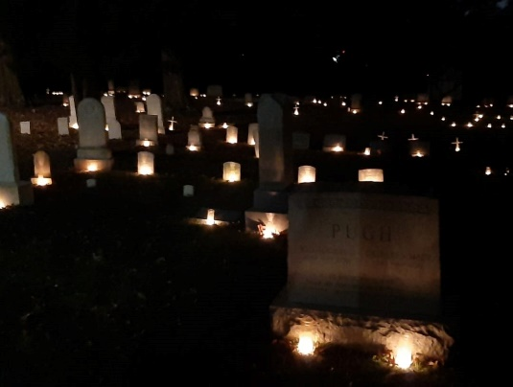

Commendation Prayers

Officiant: Give rest, O Christ, to your servants with your saints,

where sorrow and pain are no more,
neither sighing, but life everlasting.

You only are immortal, the creator and maker of humankind;
and we are mortal, formed of the earth, and to earth shall we return.
For so did you ordain when you created us, saying,
“You are dust, and to dust you shall return.” All of us go down to the dust;
yet even at the grave we make our song: Alleluia, alleluia, alleluia.

Give rest, O Christ, to your servants with your saints,
where sorrow and pain are no more, neither sighing, but life everlasting.

Officiant: Into your hands, O merciful Savior, we commend all of those who have died. Acknowledge, we humbly beseech you, sheep of your own fold, lambs of your own flock, sinners of your own redeeming. Receive them into the arms of your mercy, into the blessed rest of everlasting peace, and into the glorious company of the saints in light. Amen.

Officiant Go in peace to love and serve the Lord. Alleluia, Alleluia.
All: Thanks be to God. Alleluia, Alleluia.

